*With every Purchase of $400.00 or more*
GET YOUR NAME IN
FOR A CHANCE TO WIN
Ask our Bud Tenders for Details


$800 CASH
$4000

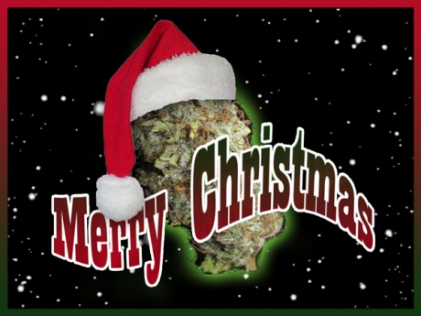
$350 text here
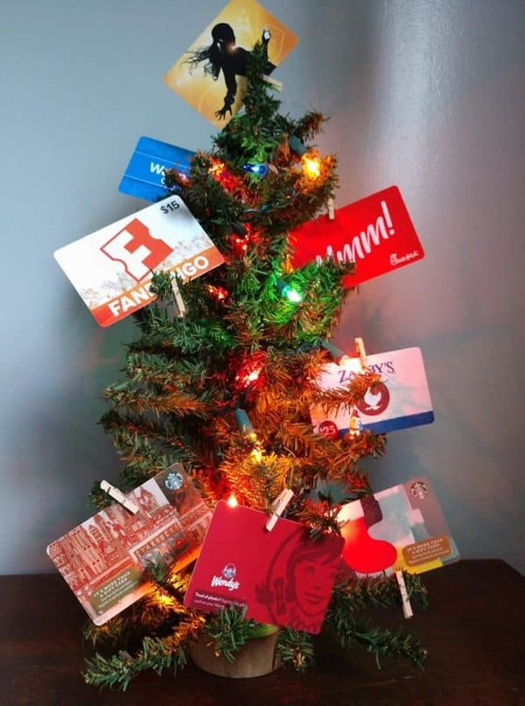
$500 Value
$100 - Sobey’s
$50- Canadian Tire
- Mark’s
- Sports Check
- WalMart
- Gas Card
$30- Movie Theatre
$25- Shoppers, Tims,
Starbucks & 2 Jake’s $20 & $25



$300
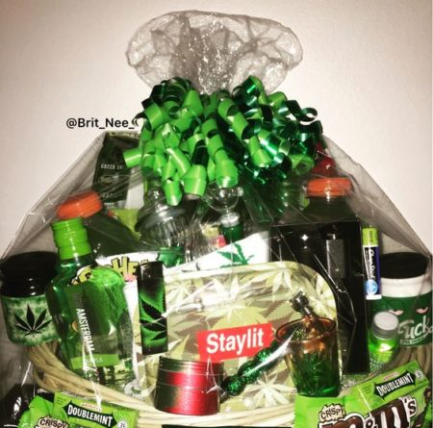

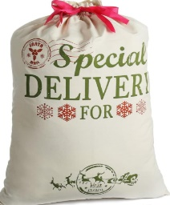

One of TWO Malpek
STONER BASKET WORTH $300
$200
SWAG BAG
$75
Mega Cannabis
Advent Calendars
(valued over $600)

